**Syllabus**

**Intro to Biochemistry Lab**

**(BCH 3023L, Section 842197)**

**(Web-Enhanced)**

**Term**: Fall 2014-1

**Class** **location**: Room A212

**Class Meeting time**: M 5:40PM – 9:00PM

Professor: Dr. Félix E. Rivera-Mariani

Office: A102, A212

Office Hours: M: 3:00PM – 5:00PM or by appointment (A102)

W: 3:00PM – 5:00PM or by appointment (A212)

**Email**: [friveram@mdc.edu](mailto:friveram@mdc.edu)

Phone: 800-319-4380

**Required Textbook:** Ferrel, S.O. and L. E. Taylor. 2006. Experiments in Biochemistry: A Hands-on Approach, 2nd Ed. Brooks/Cole Cenage Learning. Belmont, CA.

**Pre-requisite:** Organic Chemistry I (CHM 2210), Organic Chemistry I Lab (CHM2210L), Organic Chemistry II (CHM 2211), Organic Chemistry II Lab (2211L) or CHM 2200 and CHM2200L.

**Co-requisite**: Introduction to Biochemistry (BCH3023)

1. **Rationale of the course**

To complement and expand the knowledge obtained in the Introduction to Biochemistry BCH3023 course and provide hands-on experience of the laboratory and scientific approaches used to study macromolecules, such carbohydrates, proteins, nucleic acids, and lipids.

1. **Course Goals**

* To understand and properly plan and perform biochemical experiments
* To formulate hypotheses and purposes for biochemical experiments
* To accurately report findings of biochemical experiments
* To compose biochemical explanations based on experimental findings

1. **Required materials**

* Lab coat (long-sleeve)
* Two (2) find point permanent markers (e.g. Sharpies)
* Lab googles
* 10 cm plastic bendable ruler
* Bound notebook with horizontal ruled pages

1. **Course Materials**

Course materials, including syllabus, complete lectures, assignment instructions, and supplemental materials, will be available at the following websites:

* + Miami-Dade Blackboard website:

<https://mdc.blackboard.com/webapps/portal/execute/tabs/tabAction?tab_tab_group_id=_1_1>

1. **Methods of Instructions**

***Flipped classrooms***, in which digital formats of lectures and course materials will be made available to the students online prior to meeting in class.

***Pre-lab reading assignments*** will aid your preparation for the lab meeting, and in understanding the topics and methods to be covered in the lab. A series of online questions designed by the professor, and they must be answered prior to the lab meeting.

***Laboratory Exercises*** will be performed during each lab meeting, and a corresponding report must be turned in according to the syllabus schedule.

***Group work*** to facilitate the discussion of laboratory methods, and examination and interpretations of laboratory results.

1. **Academic Integrity**

Each student is expected to maintain a high level of integrity and abide by the procedure 4070 of the Miami-Dade College Student Rights and Responsibility Handbook. Any work submitted by a student in this course for academic credit will be the student's own work. For the purpose of this course, collaboration is allowed in the following instances:in-class group work, case studies discussions, or when stated by the professor. Nevertheless, each student must submit their individual work unless stated otherwise by the instructor.

As part of a collaborative and encouraging classroom, you are encouraged to study together and to discuss topics and concepts covered in class with other students. You can obtain "consulting" help from students as well as provide "consulting" help to other students. However, this allowed form of cooperation should never involve one student having possession of a copy of all or part of the work done by another student or someone else, in the form digital files or hard copy documents.

In the case that copying occur, both the student who copied work from another student and the student who contributed to this behavior will both automatically receive a zero for the corresponding assignment. Penalty for violation of this Code can include failure of the course and/or notifying the corresponding University authorities for disciplinary action.

During exams (i.e. quizzes and exams), you must do your own work. Talking or discussion is not allowed during the examinations. In addition, you cannot compare papers, copy from others, or collaborate in any way. Any form of the behaviors mentioned above will result in failure of the exam and can include notifying the corresponding University authorities for disciplinary action. **Cell phones cannot leave the classroom during exams or quizzes, and must be turned off during class.**

Any form of Academic Dishonesty listed in the Miami-Dade College Student Rights and Responsibility Handbook will not be accepted during in the course.

**Attendance**

Attendance to each class sessions is essential for your learning. Biochemistry is known for its hard topics that often require integration of topics discussed in previous class sessions. In addition, **attendance will count 20 points of your final grade**. For each unexcused absence, **1 point will be deducted**; **for each unexcused tardiness, 0.5 point will be deducted.** It is the instructor’s decision if the student is allowed to make up missed work. In the event of an absence, the student will be allowed to make up work if the absence results from one of the following:

* Official campus activities (as designated by MDC)
* Family or personal emergencies (as designated by MDC)
* Medical reasons (discussed with the instructor)
* Work-related reasons (discuss with the instructor)

If absent during an exam, the student must make up the exam within 24hrs of the corresponding exam date except for any unusual circumstances (in accordance with MDC guidelines). **There is no make-up for quizzes.**

**Late policy**

Unless arrangement have been made prior to the due date or have a valid absence excuse (as stated in the Attendance section of this syllabus), half the grade or the corresponding points (e.g. writing assignment) will be deducted from the late assignment.

**Accommodations for students with disabilities**

In compliance with the Miami-Dade College and the Student Rights and Responsibility Handbook policy and equal access laws, I more than available to discuss any necessary academic accommodations that may be required for the student with disabilities. Requests for academic accommodations are to be made during the first week of the term, except for unusual circumstances, so arrangements can be made. Students are encouraged to contact the Student Services to verify their eligibility for appropriate accommodations.

**Inclusivity Statement**

Members (student, faculty, administrators) of the MDC community represent a diversity of backgrounds and perspectives. In this course, and as a member of this community, I am a strong supporter of diversity and its benefits. Therefore, to maintain an adequate learning and diverse environment students in this course are strongly encouraged to:

* share their unique beliefs, experiences, and values
* be open to the opinions and views of others
* honor your colleagues’ uniqueness
* appreciate the unique opportunity we have to learn from each other
* value each other’s opinions and communicate in a respectful manner
* keep confidential discussions that the community has of a personal (or professional) nature
* take advantage of this opportunity to share ways in which an inclusive environment can be create in this course and across the MDC community

**Grading Scales:**

|  |  |
| --- | --- |
| **Item** | **Points** |
| Pre Lab Reading (weekly) | 50 |
| Lab Reports | 100 |
| Quizzes (every 3-4 weeks) | 40 |
| Lab Skill Evaluation | 100 |
| Attendance | 20 |
| Midterm exam | 50 |
| Final exam | 50 |
| **Total points** | **400** |

|  |  |  |
| --- | --- | --- |
| **Grade** | **Percentage** | **Points** |
| A | 100 – 90% | 360 |
| B | 89 – 80% | 320 |
| C | 79 – 70% | 280 |
| D | 69 – 60% | 240 |
| F | Below 60% | Below 240 |

|  |  |
| --- | --- |
| *iClickerTM questions (bonus points)* | *20* |

**Pre-lab reading**

Prior to meeting for class, the professor will upload pre-lab questions into the MDC Blackboard LearnTM website of the course. Each student must answer them independently, and submit them before the lab session. Each question must be answered in complete sentences. Points will be deducted as follows:

* **0.5 point** for answering in incomplete sentences
* **0.5 point** for incorrect answers for the pre-lab questions

**Lab Reports (10 points each)**

For each lab exercise, there is a lab report that must be completed and turned in. Due dates for each lab report are listed on the syllabus schedule as well as on the Blackboard website of the course. **Answers must be in complete sentences**. If mistakes are made on the lab reports**, the students must cross the mistake with a single line, initialize the crossed mistake, and write the correct answer or data**. No pencil, **only black ink.** Points will be deducted for the following:

* **0.5 point** for answering in incomplete sentences
* **0.5 point** for unanswered questions in the lab report
* **0.5 point** for incorrectly answering a question in the lab report
* **0.5 point** for not properly crossing a mistake on the lab report
* **1 point** for not using black ink

**Lab reports can be submitted in hard copy, or as a digital file into a DropboxTM folder to be assigned for each corresponding lab report.**

**Attendance (20 total points)**

As stated earlier in the syllabus, attendance counts for a grade. Points will be deducted as follows:

* **1 point** for unexcused absence
* **0.5 point** for unexcused tardiness

**Quizzes (every 3-4 weeks; 10 points each):**

Quizzes (refer to the schedule on this syllabus) will assess the student’s skills and knowledge gained from the previous 3-4 lab sessions. It will also serve to keep the student studying during the course, serve as a review for the Midterm and Final Exams. Quizzes will be either on hard copy or html (webpage) to be completed in the lab.

**iClicker Questions (2 per week; 1.25 points each; 20 bonus points total)**

The purpose of iClickerTM question is to assess a student’s knowledge *in-class* and to contribute a scenario for Team-Based learning. Questions will be presented while in class and students will answer through smartphone app. More importantly, students will have the opportunity to discuss the questions between peers before answering the question.

**Lab Skills Evaluation**

|  |  |  |
| --- | --- | --- |
|  | Lab Skill Evaluations | Points |
| I | Pipetting | 10 |
| II | Weighting | 10 |
| III | Clean Working Area | 10 |
| IV | Lab Notebook | 70 |

**Lab Notebook**

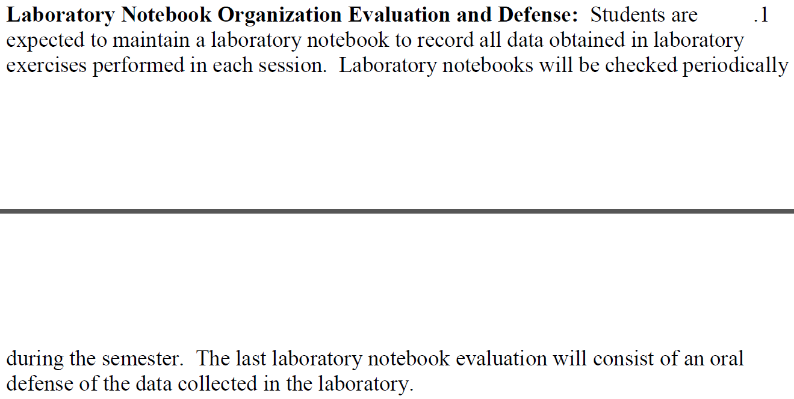



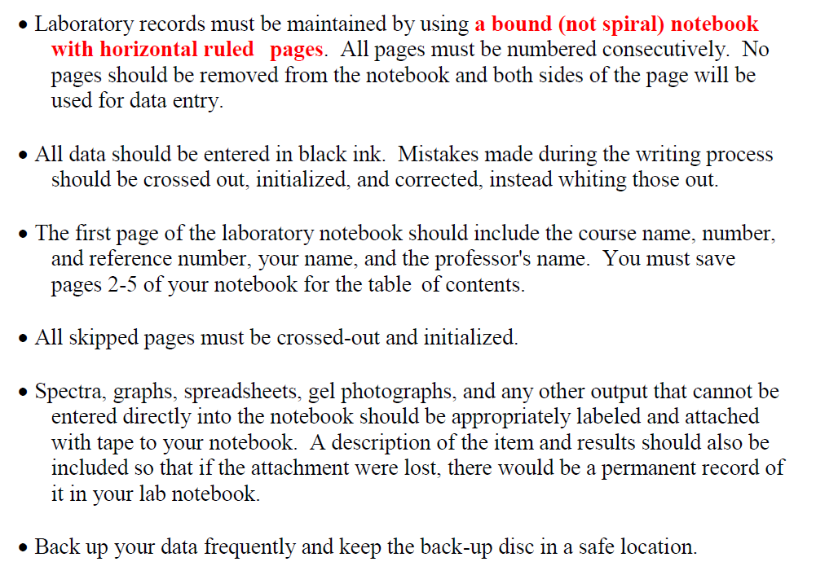

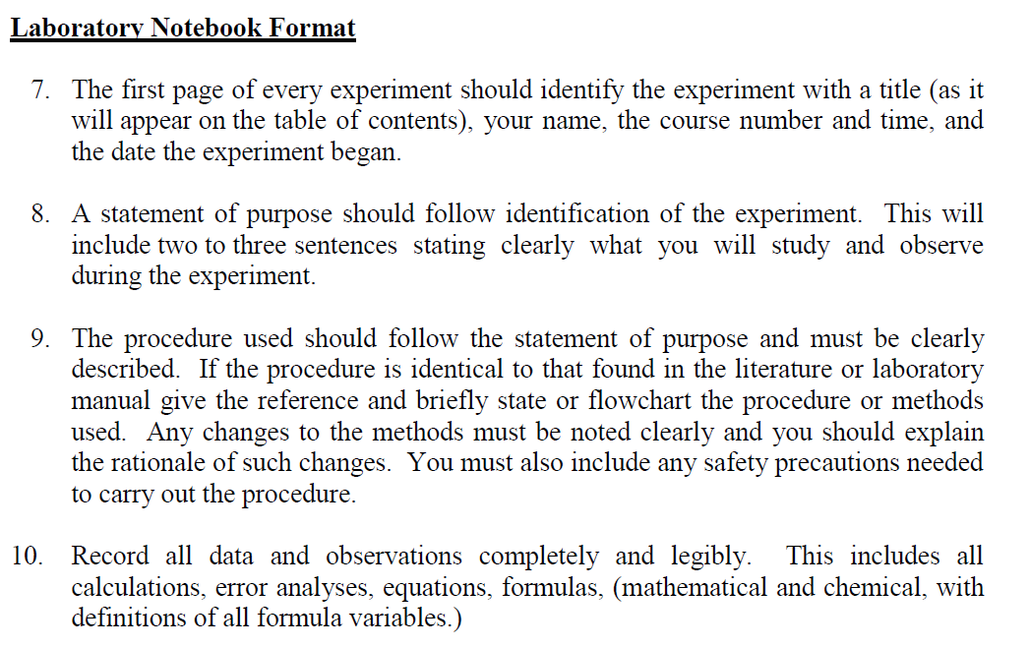

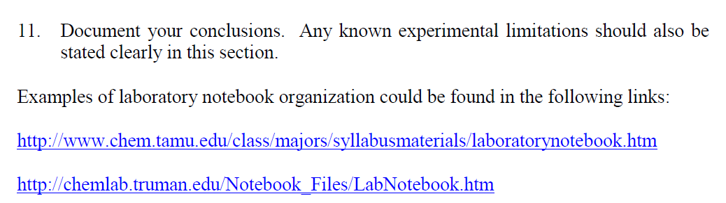

***Source for lab notebook format: Dr. Clemente Fernández***

**Exams**

Two 50 points exams (Midterm and Final) will be administrated during regular laboratory periods. Refer to the syllabus schedule to know the dates of the exams. Each of the exams will be multiple choice questions. No scantrons are needed: questions will be answered on the printed exam provided. In case a calculator is needed for a given question, each student must bring their own calculator: **no shared calculators will be allowed and cellphones will not be allowed to be used as calculators**.

At the next lab sessions, the students will received a Scorecard of the exam and copy of the exam: **exams must be returned to the professor and cannot be photographed**. Academic Dishonesty regulations, as stated in the MDC student handbook, will be strictly enforced. Any violations will result in a zero on the exam.

**There are no make-ups for Exams.**

**Tentative Course Schedule**

***(pre-lab questions will notify the corresponding pages of the experiment)***

|  |  |  |  |
| --- | --- | --- | --- |
| **Date** | **Week** | **Topic** | **Assignments Due Dates** |
| Aug-27 | W1 | -Lab Orientation and Safety  -Concentration calculation  -Pipetting  -Balance |  |
| **Sep-03** | **W2** | -Pipetting, Balance  -Lab Skill Evaluation: Pipetting, Balance  -Start Lab Notebook  **-Quiz (Flipped Classroom: Pipetting)** | **-Pipetting pre-lab**  **-Lab Safety Report** |
| Sep-10 | W3 | -Accuracy and Precision | **-Pipetting/Balance report** |
| ***Sep-17*** | ***W4*** | -Acid, Bases, Buffer | **-Acid, Base, Buffer pre-lab**  **-*Quiz #1*** |
| Sep-24 | W5 | -Spectrophotometry  -Beer’s Law  -Standard Curves  -Bradford Assay | **-Spectrophotometry pre-lab**  -**Acid, bases, buffer repor**t |
|  |  |  |  |
| ***Oct-01*** | ***W6*** | -Purifying LDH  -Centrifugation | -**LDH pre-lab**  **-Spectrophotometry report**  **-*Quiz #2*** |
| Oct-08 | W7 | -Purifying LDH  -Salting out and dialysis |  |
|  |  |  |  |
| **Oct-15** | **W8** | **-Midterm** | -**LDH Report** |
| Oct-22 | W9 | -Enzyme kinetics  -LDH activity in two directions | **-Enzyme Kinetics pre-lab** |
|  |  |  |  |
| Oct-29 | W10 | -Specific enzyme activity  -Km calculations | -**Effect of temp, pH pre-lab**  **-Enzyme kinetics report** |
|  |  |  |  |
| ***Nov-05*** | ***W11*** | -Effect of Temperature and PH  -Effect of substrate concentration | **-Temperature, pH, substrate pre-lab**  **-Enzyme activity/km report**  ***-Quiz #3*** |
| Nov-12 | W12 |  |  |
| Nov-19 | W13 | -Chromatography  -TLC, size exclusion Chromatography | -**Chromatography pre-lab**  -**Temp, pH, substrate report** |
| Nov-26 | W14 | -Electrophoresis  -Comparative proteomics | -**Electrophoresis pre-lab**  -**Chromatography Report** |
| ***Dec-03*** | ***W15*** | -Review | **-Electrophoresis report**  **-Proteomics report**  ***-Quiz #4*** |
|  |  |  |  |
| **Dec-10** | **W16** | **-Final exam (comprehensive)** |  |
| Dec-17 | W17 |  |  |
|  |  |  |  |